Digital Promotion Toolkit

World No Tobacco Day – May 31, 2018

The National Cancer Institute (NCI) is partnering with organizations from across the globe to call attention to World No Tobacco Day (WNTD) on Thursday, May 31. Sponsored by the World Health Organization (WHO), WNTD is an opportunity for the world to unite together to raise awareness about tobacco-related death and disease. Below find sample WNTD social media posts, please feel free to tailor to your specific social media audience.

Text | Image
Today we recognize the tobacco epidemic as one of the biggest public health treats to the world. #WorldNoTobaccoDay advocates for improved awareness and action against tobacco-related death and disease https://go.usa.gov/xQPbW #NoTobacco | 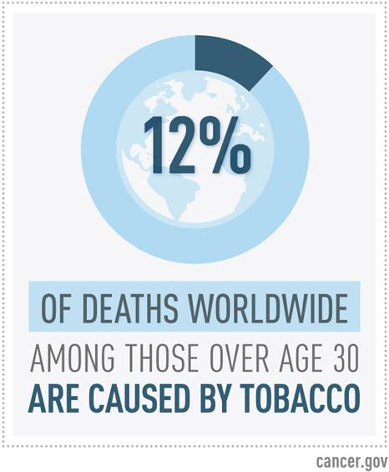
In addition to health risks like cancer and cardiovascular disease, women who use tobacco are also at risk for reproductive health side effects, including reduced fertility. Learn more about #WorldNoTobaccoDay: https://go.usa.gov/xQPbW | 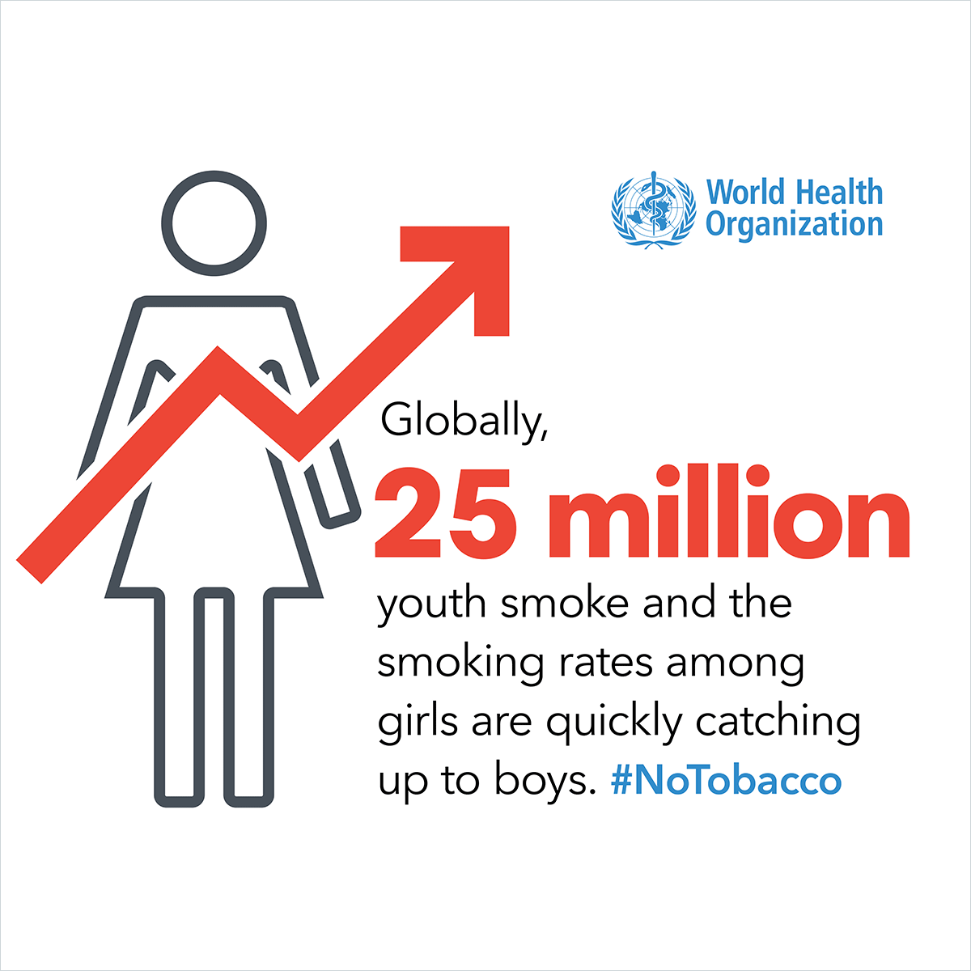
Worldwide, there are over one billion tobacco users, and millions die every year from tobacco-related illnesses. Join @WHO and @NCIGlobalHealth in recognizing #WorldNoTobaccoDay on May 31 https://go.usa.gov/xQPbW | 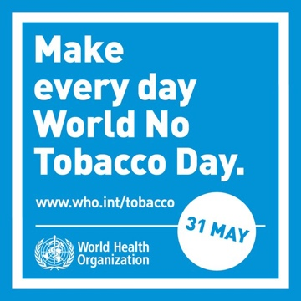

When drafting Twitter content, we ask that you use the hashtags: #WorldNoTobaccoDay and #NoTobacco

